**Project 2**

**Storyboard an educational science lesson for 1st grade students**

**1st Grade Level Science Lesson**

**Ocean Creatures**

Student Name: Michael Longo

Date:11/4/2016

**Lesson Interactivity Flow Chart**

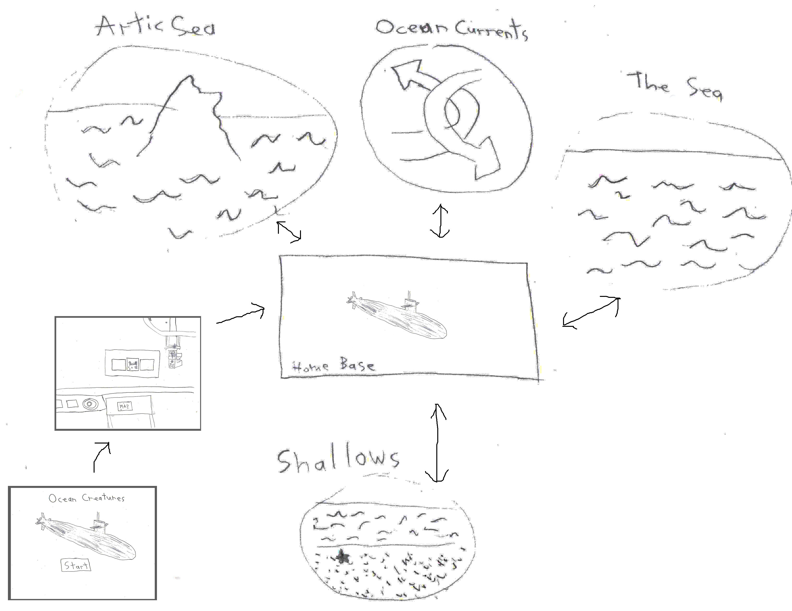

|  |  |
| --- | --- |
| **Part I: Introduction** | |
| **Scene 1: Title Screen** | **Text, Narration, Sounds** |
|  | **"Ocean Creatures" displays as the title. There is also a "Start" button.**  **Sounds:**  **The title screen music is playing. There is a bubbles sound when the**  **Players clicks the start button.** |
| **Notes: This is the title screen.** |
| **Part I: Introduction** | |
| **Scene 2: Submarine Operations Room** | **Text, Narration, Sounds** |
|  | **The computer:**  **"Hello. Welcome to the submarine. Here to research marine wildlife? I can help. Just check the map on the table to tell me where you want to go."**  **Sounds:**  **There is a radar idle sound.** |
| **Notes: The computer is a helper to the player meant to be a guide.** |

|  |  |
| --- | --- |
| **Part 2: Exploration** | |
| **Scene 1: Map** | **Text, Narration, Sounds** |
|  | **The player looks over the map and clicks on one of the locations. The four research location are the Artic Sea, Ocean Currents, The Sea, and the Shallows.**  **Sounds:**  **When hovering over a map, each of the 4 research locations has a sound. The Artic Sea has cold wind sound. Ocean Currents had a ping radar sound. The Sea has a bubbles sound. The Shallows has a sand footsteps sound.** |
| **Notes: The map has a base destination and 4 research destinations. It should be noted that the player can visit them in any order.** |
| **Part 2:Exploration** | |
| **Scene 1A: Arctic Sea** | **Text, Narration, Sounds** |
|  | **The player sees an environment with 5 creatures. The computer gives the information (and narrates it) based on the chart. The text appears on the bottom of the screen beneath the picture. The player clicks on each creature to get information about them.**  **When a creature is clicked on, it makes a sound similar to what it would in the wild. If it doesn’t make any sound, then that would be substituted with a splash sound or a bubbles sound.** |
| **Notes: This has information on aquatic mammals.** |
| **Part 2:Exploration** | |
| **Scene 1B: Ocean Currents** | **Text, Narration, Sounds** |
|  | **The player sees an environment with 5 creatures. In this case, it is through the microscopic view. The computer gives the information (and narrates it) based on the chart. The text appears on the bottom of the screen beneath the picture. The player clicks on each creature to get information about them.**  **When a creature is clicked on, it makes a sound similar to what it would in the wild. If it doesn’t make any sound, then that would be substituted with a splash sound or a bubbles sound.** |
| **Notes: This has information on plankton.** |
| **Part 2:Exploration** | |
| **Scene 1C: The Sea** | **Text, Narration, Sounds** |
|  | **The player sees an environment with 5 creatures. The computer gives the information (and narrates it) based on the chart. The text appears on the bottom of the screen beneath the picture. The player clicks on each creature to get information about them.**  **When a creature is clicked on, it makes a sound similar to what it would in the wild. If it doesn’t make any sound, then that would be substituted with a splash sound or a bubbles sound.** |
| **Notes: This has information about fish.** |
| **Part 2: Exploration** | |
| **Scene 1D: The Shallows** | **Text, Narration, Sounds** |
|  | **The player sees an environment with 5 creatures. The computer gives the information (and narrates it) based on the chart. The text appears on the bottom of the screen beneath the picture. The player clicks on each creature to get information about them.**  **When a creature is clicked on, it makes a sound similar to what it would in the wild. If it doesn’t make any sound, then that would be substituted with a splash sound or a bubbles sound.** |
| **Notes: This has information about shellfish.** |
| **The Chart** | |
|  | **Text, Narration, Sounds** |
| |  |  |  |  |  |  |  | | --- | --- | --- | --- | --- | --- | --- | | **mammals** | **blue whale** | **narwhale** | **orca** | **dolphin** | **seal** |  | | *air:* | surface breather | surface breather | surface breather | surface breather | surface breather |  | | *shelter:* | open sea, size | tusk, ice shelfs | pods | pod (groups) | land/ice |  | | *food:* | krill, zooplankton | flatfish, cod, halibut | fish, mammals, seabirds, turtles | fish, squid | fish, shellfish, zooplankton, sea birds | | |  |  |  |  |  |  |  | | **fish** | **great white shark** | **hammerhead** | **salmon** | **sardine** | **clownfish** |  | | *air:* | gills | gills | gills | gills | gills |  | | *shelter:* | open sea | open sea | schools | schools | sea anemone |  | | *food:* | fish/sea mammals/sea birds | fish/shark, cephalopods, crustaceans | small fish, krill, crustaceans | zoo plankton | plankton, algae, undigested anemone food | | |  |  |  |  |  |  |  | | **shellfish** | **crab** | **hermit crab** | **lobster** | **shrimp** | **clams** |  | | *air:* | gills | gills | gills | gills | gills |  | | *shelter:* | armor, claws, burrows | shell, claws, terrain | armor, claws | armor, claw, fast swimming, burrows | shells, digging |  | | *food:* | algae, mollusks, worms | algae, plankton, scavenging | fish, mollusks, worms, plant | seaweed, plankton, worms, prey | plankton |  | |  |  |  |  |  |  |  | | **plankton** | **krill** (zooplankton) | **eel larvae** (zooplankton) | **salmon fry** (zooplankton) | **blue-green algae** (phytoplankton) | **dinoflagellates** (phytoplankton) |  | | *air:* | gills | gills | gills | carbon dioxide from water | carbon dioxide from water |  | | *shelter:* | swarming | swarming | swarming | algae blooms, sometimes poison | swarming, tail-like flagellas |  | | *food:* | phytoplankton, small zooplankton | phytoplankton | yolk remains, phytoplankton | chlorophyll/photo-synthesis | chlorophyll/photo-synthesis |  |  |  |  |  |  |  |  |  | | --- | --- | --- | --- | --- | --- | --- | | **mammals** | **blue whale** | **narwhale** | **orca** | **dolphin** | **seal** |  | | *air:* | surface breather | surface breather | surface breather | surface breather | surface breather |  | | *shelter:* | open sea, size | tusk, ice shelfs | pods | pod (groups) | land/ice |  | | *food:* | krill, zooplankton | flatfish, cod, halibut | fish, mammals, seabirds, turtles | fish, squid | fish, shellfish, zooplankton, sea birds | | |  |  |  |  |  |  |  | | **fish** | **great white shark** | **hammerhead** | **salmon** | **sardine** | **clownfish** |  | | *air:* | gills | gills | gills | gills | gills |  | | *shelter:* | open sea | open sea | schools | schools | sea anemone |  | | *food:* | fish/sea mammals/sea birds | fish/shark, cephalopods, crustaceans | small fish, krill, crustaceans | zoo plankton | plankton, algae, undigested anemone food | | |  |  |  |  |  |  |  | | **shellfish** | **crab** | **hermit crab** | **lobster** | **shrimp** | **clams** |  | | *air:* | gills | gills | gills | gills | gills |  | | *shelter:* | armor, claws, burrows | shell, claws, terrain | armor, claws | armor, claw, fast swimming, burrows | shells, digging |  | | *food:* | algae, mollusks, worms | algae, plankton, scavenging | fish, mollusks, worms, plant | seaweed, plankton, worms, prey | plankton |  | |  |  |  |  |  |  |  | | **plankton** | **krill** (zooplankton) | **eel larvae** (zooplankton) | **salmon fry** (zooplankton) | **blue-green algae** (phytoplankton) | **dinoflagellates** (phytoplankton) |  | | *air:* | gills | gills | gills | carbon dioxide from water | carbon dioxide from water |  | | *shelter:* | swarming | swarming | swarming | algae blooms, sometimes poison | swarming, tail-like flagellas |  | | *food:* | phytoplankton, small zooplankton | phytoplankton | yolk remains, phytoplankton | chlorophyll/photo-synthesis | chlorophyll/photo-synthesis |  | | **The chart is meant to show information of the creatures. When the player clicks on a creature, the information in the chart for that creature pops up as text at the bottom of the screen. It is also narrated by the computer.**  **Below is a non cut off version so that the whole information can be seen. To clarify, the chart itself is not in the game. Only the text of information pertaining to the creature is shown, and only when it is clicked on.** |
| **Notes: When a creature’s information is shown, the categories on the left most column are shown as well.** |